INTERNSHIP CODTECH

TASK -1 FILE HANDLING UTILITY
import java.io.*;

public class FileHandlingUtility {
public static void writeToFile(String fileName, String content) {
try {
BufferedWriter writer = new BufferedWriter(new FileWriter(fileName));
writer.write(content);
writer.close();
System.out.println("File written successfully.");
} catch (IOException e) {
System.out.println("Error while writing to file: " + e.getMessage());
}
}
public static void readFromFile(String fileName) {
try {
BufferedReader reader = new BufferedReader(new FileReader(fileName));
String line;
System.out.println("\nReading file content:");
while ((line = reader.readLine()) != null) {
System.out.println(line);
}
reader.close();
} catch (IOException e) {
System.out.println("Error while reading file: " + e.getMessage());
}
}

public static void modifyFile(String fileName, String newContent) {
try {
BufferedWriter writer = new BufferedWriter(new FileWriter(fileName, true));
writer.newLine();
writer.write(newContent);
writer.close();
System.out.println("\nFile modified successfully.");
} catch (IOException e) {
System.out.println("Error while modifying file: " + e.getMessage());
}
}
public static void main(String[] args) {

String fileName = "sample.txt";
writeToFile(fileName, "This is the initial content of the file.");
readFromFile(fileName);
modifyFile(fileName, "This content is appended to the file.");
readFromFile(fileName);
}
}

OUTPUT:
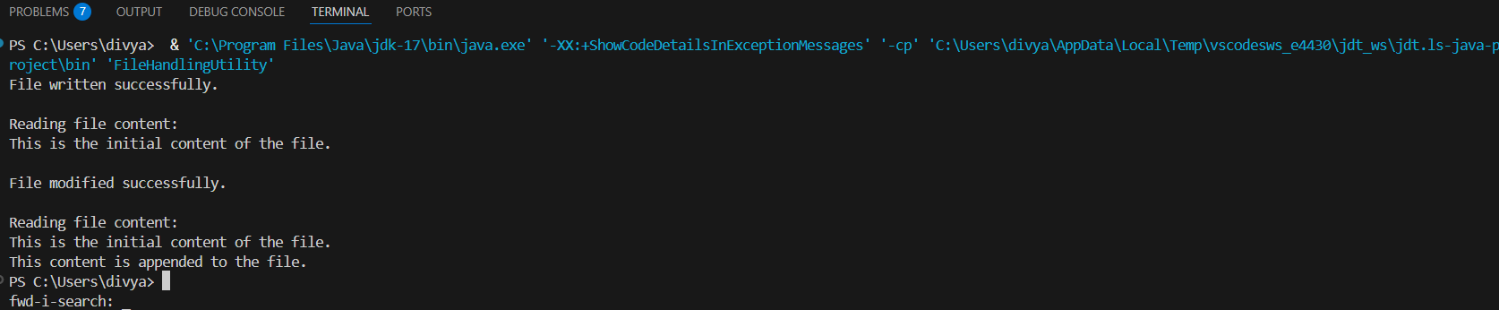
TASK -2
REST API CLIENT
import java.net.URI;
import java.net.http.HttpClient;
import java.net.http.HttpRequest;
import java.net.http.HttpResponse;

import org.json.JSONObject;

public class RestApiClient {

public static void main(String[] args) {
try {
String apiUrl = "https://api.open-meteo.com/v1/forecast"
+ "?latitude=28.61"
+ "&longitude=77.20"
+ "&current_weather=true";

HttpClient client = HttpClient.newHttpClient();

HttpRequest request = HttpRequest.newBuilder()
.uri(URI.create(apiUrl))
.GET()
.build();

HttpResponse<String> response = client.send(
request,
HttpResponse.BodyHandlers.ofString());

JSONObject jsonResponse = new JSONObject(response.body());
JSONObject currentWeather = jsonResponse.getJSONObject("current_weather");

double temperature = currentWeather.getDouble("temperature");
double windSpeed = currentWeather.getDouble("windspeed");
int weatherCode = currentWeather.getInt("weathercode");

System.out.println("===== Current Weather Report =====");
System.out.println("Temperature : " + temperature + " °C");
System.out.println("Wind Speed : " + windSpeed + " km/h");
System.out.println("Weather Code: " + weatherCode);
System.out.println("=================================");

} catch (Exception e) {
e.printStackTrace();
}
}
}

OUTPUT :
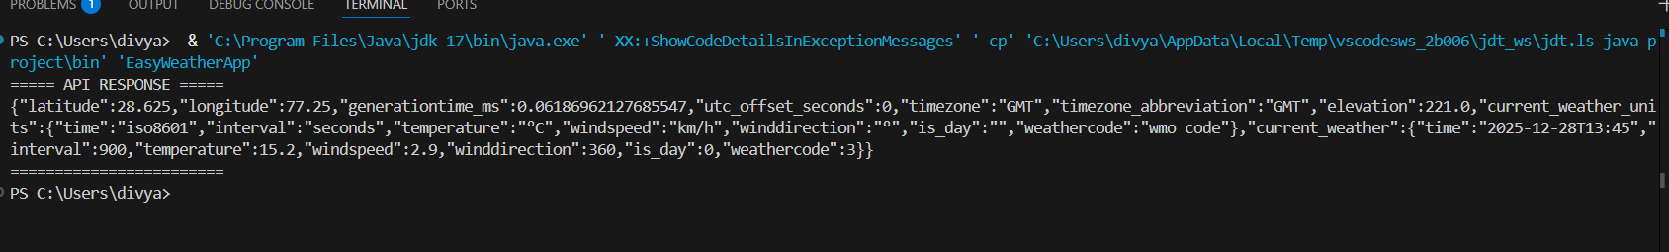

TASK -3

BUILD A CLIENT-SERVER CHAT APPLICATION
USING JAVA SOCKETS AND
MULTITHREADING TO HANDLE MULTIPLE
USERS.
import java.io.*;
import java.net.*;

public class ChatClient {

private static final String SERVER_IP = "127.0.0.1";
private static final int SERVER_PORT = 12345;

public static void main(String[] args) {
try (Socket socket = new Socket(SERVER_IP, SERVER_PORT)) {
BufferedReader userInput = new BufferedReader(new InputStreamReader(System.in));
BufferedReader in = new BufferedReader(new InputStreamReader(socket.getInputStream()));
PrintWriter out = new PrintWriter(socket.getOutputStream(), true)
Thread readThread = new Thread(() -> {
try {
String serverMessage;
while ((serverMessage = in.readLine()) != null) {
System.out.println(serverMessage);
}
} catch (IOException e) {
System.out.println("Connection closed.");
}
});
readThread.start();
String message;
while ((message = userInput.readLine()) != null) {
out.println(message);
if (message.equalsIgnoreCase("/quit")) {
break;
}
}

socket.close();
System.exit(0);

} catch (IOException e) {
System.out.println("Error connecting to server: " + e.getMessage());
}
}
}

OUTPUT :
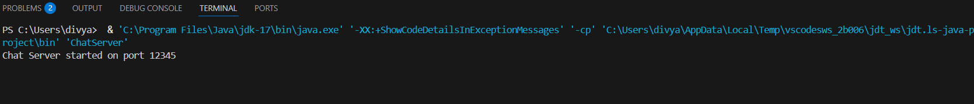

CHAT CLIENT
import java.io.*;
import java.net.*;

public class ChatClient {

private static final String SERVER_IP = "127.0.0.1";
private static final int SERVER_PORT = 12345;

public static void main(String[] args) {
try (Socket socket = new Socket(SERVER_IP, SERVER_PORT)) {
BufferedReader userInput = new BufferedReader(new InputStreamReader(System.in));
BufferedReader in = new BufferedReader(new InputStreamReader(socket.getInputStream()));
PrintWriter out = new PrintWriter(socket.getOutputStream(), true);

// Thread to read messages from server
Thread readThread = new Thread(() -> {
try {
String serverMessage;
while ((serverMessage = in.readLine()) != null) {
System.out.println(serverMessage);
}
} catch (IOException e) {
System.out.println("Connection closed.");
}
});
readThread.start();

// Main thread to send messages
String message;
while ((message = userInput.readLine()) != null) {
out.println(message);
if (message.equalsIgnoreCase("/quit")) {
break;
}
}

socket.close();
System.exit(0);

} catch (IOException e) {
System.out.println("Error connecting to server: " + e.getMessage());
}
}
}
OUTPUT:

TASK -4
AI-BASED RECOMMENDATION SYSTEM
import org.apache.mahout.cf.taste.common.TasteException;
import org.apache.mahout.cf.taste.impl.model.file.FileDataModel;
import org.apache.mahout.cf.taste.impl.neighborhood.NearestNUserNeighborhood;
import org.apache.mahout.cf.taste.impl.recommender.GenericUserBasedRecommender;
import org.apache.mahout.cf.taste.impl.similarity.PearsonCorrelationSimilarity;
import org.apache.mahout.cf.taste.model.DataModel;
import org.apache.mahout.cf.taste.neighborhood.UserNeighborhood;
import org.apache.mahout.cf.taste.recommender.RecommendedItem;
import org.apache.mahout.cf.taste.recommender.UserBasedRecommender;
import org.apache.mahout.cf.taste.similarity.UserSimilarity;

import java.io.File;
import java.util.List;

public class RecommendationSystem {

public static void main(String[] args) {
try {

DataModel model = new FileDataModel(new File("ratings.csv"));

UserSimilarity similarity = new PearsonCorrelationSimilarity(model);

UserNeighborhood neighborhood = new NearestNUserNeighborhood(2, similarity, model);

// Create recommender
UserBasedRecommender recommender = new GenericUserBasedRecommender(model, neighborhood, similarity);

// Get recommendations for user 1
List<RecommendedItem> recommendations = recommender.recommend(1, 3);

System.out.println("Recommended items for User 1:");
for (RecommendedItem recommendation : recommendations) {
System.out.println("Item ID: " + recommendation.getItemID()
+ " | Score: " + recommendation.getValue());
}

} catch (Exception e) {
e.printStackTrace();
}
}
}
OUTPUT:

Recommended items for User 1:
Item ID: 104 | Score: 4.6
Item ID: 102 | Score: 3.9
Item ID: 101 | Score: 3.4

